X990 (display 1920x1080) has Libre 24.2.6.2 on ubuntuMATE 24.04
HP2510 (display 1280x800) has Libre 6.4.7.2 on ubuntuMATE 20.04
E15 (display 1920x1080) has Libre 7.6.7.2 on Windows 10
I3891 (display 1280x1024) has Libre 24.2.3.2 on Windows 10

X990
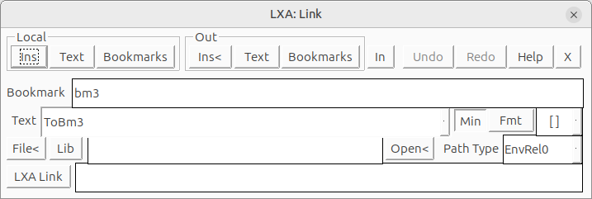
HP2510
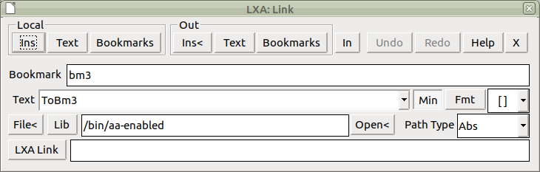

E15
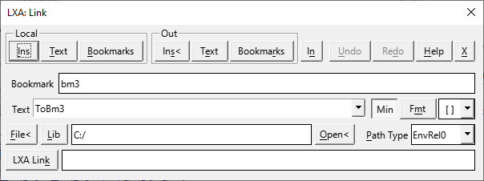

I3891


