- Default, which is Level 1

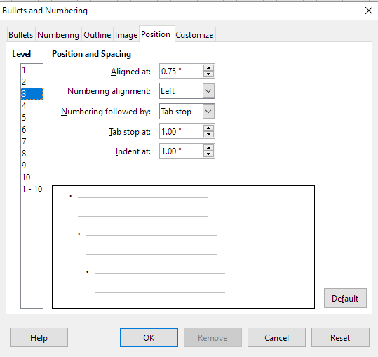
- Level 3 selected, result is Default Level 1
Not possible to change the Default or to change or add other Levels

