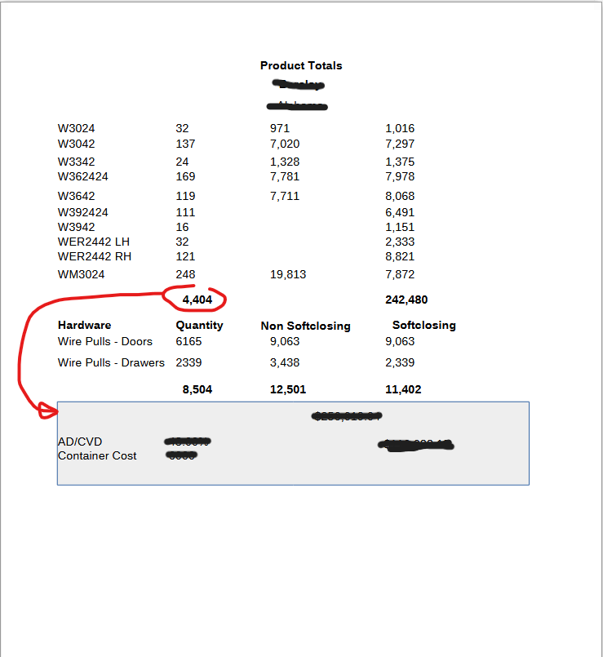
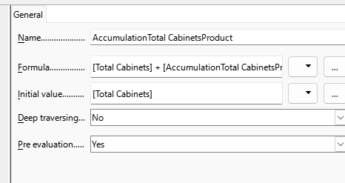
I need only the total quantity of cabinets in the report footer here. Then, that has to be divided by 400 to get the number of containers required for shipping.

