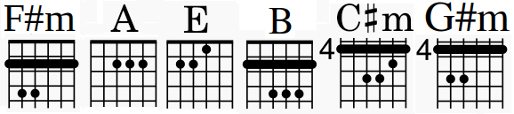
(F#m – Audio)
(F#m - Inf)
Across The Universe Mosaic
♩= 88 Key = D
5 6 7 1 2 3 4
A A# Bb B C C# Db D D# Eb E F F# Gb G G# Ab
A A# Bb B C C# Db D D# Eb E F F# Gb G G# Ab

Am B^{Ʌ7} C⁶

