Soviet Tank Armies
by John M. Astell; Copyright © 2026 John M. Astell
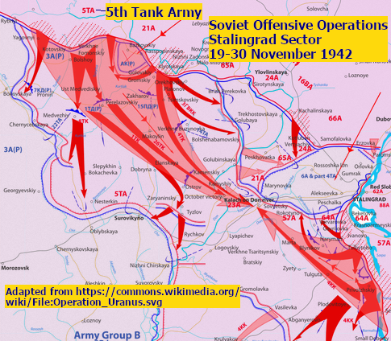
In May 1942, the Soviets began forming tank armies to improve the operations of large tank forces (the tank and mechanized corps; see the previous article). Each army controlled and coordinated the operations of up to three of these corps. (At first, only tank corps were available; mechanized corps became available in late 1942.)
The newly formed tanks corps and tank armies encountered serious challenges in the summer of 1942. They were thrown in to try to halt the German 1942 summer offensive, and they suffered heavy losses. For example, the Soviets formed four tank armies in 1942, with three of them (the 1st, 4th, and 5th) effectively being destroyed in combat in 1942, each time with the tank army having to be reformed anew later. This was due the severity of fighting on the Eastern Front in 1942 rather than a sign that the tank army concept was flawed. The tank armies could function effectively and successfully in 1942. For example, mechanized forces of the 5th Tank Army were instrumental in surrounding the German 6th Army at Stalingrad in November 1942.
The Soviets were still rebuilding the armor forces throughout 1942. They had suffered huge tank losses in 1941, while many tank factories had cease production and be evacuated to escape capture by the Germans. It would take many months before a relocated factory could resume full production. To increase the tank armies’ strengths, the Soviets often included substantial non-motorized forces like rifle and cavalry units in the tank armies. These forces could help a tank army break through the enemy front lines, but they could not keep up with the tanks once the tanks exploited the breakthrough and drive into the enemy rear areas. This is what happened, for example, when the 5th Tank Army broke through the German defense north of Stalingrad in November 1942: the mechanized forces raced into the German rear to cut off the Germans in Stalingrad, while the non-motorized forces lagged behind.
The Red Army refined its tank army doctrine in January 1943, decreeing that non-motorized combat forces be (mostly) excluded from the tank armies. This allowed the tank armies to concentrated on mechanized operations. Sometimes, a few non-motorized units were attached to a tank army as circumstances required, but not large numbers of non-motorized units as had sometimes been the case in 1942. Also that month, the Soviet high command ordered the formation of ten tank armies, each to have two tank corps and one mechanized corps plus supporting smaller forces like motorized rocket artillery launchers. This plan proved wildly over-ambitious, as events that winter would soon show.
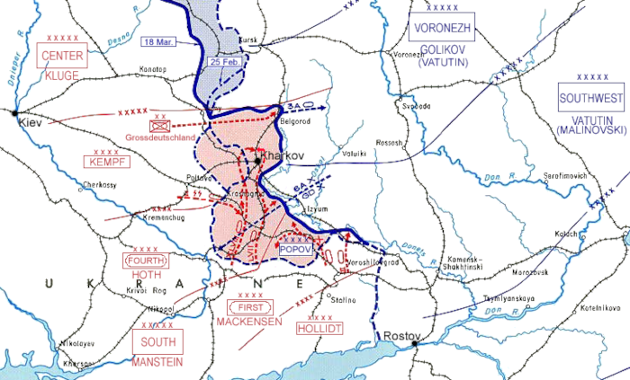
German counteroffensive, February-March 1943
(source: https://commons.wikimedia.org/wiki/File:Third_Battle_of_Kharkov_sector.png)
The Soviet offensives around Stalingrad had routed the Axis in the southern half of the Eastern Front. During the winter, Soviet mechanized forces were racing west in hopes of crossing the Dnepr River and collapsing the Axis position there entirely. Instead, the Germans launched a winter counteroffensive that smashed the Soviet armored spearheads and threw the Red Army back on the defensive. Two tanks armies were effectively destroyed (the 3rd and the reformed 5th). While this was the last time Soviet tank armies would be destroyed, it foreshadowed that Soviet mechanized forces would continue to experience hard combat and heavy losses for the rest of the war.
The Soviets simply did not have the resources to maintain ten tank armies plus all the separate tank and mechanized corps the fronts and infantry armies needed. The Red Army simply was not able to raised ten tank armies, and the high command order decreeing this was quietly dropped. (So quietly that even today many Russian-language sources on the order do not mention it was not implemented!) The best the Red Army could do was to have six tank armies from 1944, some with only had two corps instead of three.
All the tank armies eventually became Guards Tank Armies, in honor of their exploits. Typically, when the Soviets promoted a formation to Guards status, it got a new unit ID in the Guards sequence and its regular ID became available to be reissued. For example, the 21st Army became the 6th Guards Army in April 1943, and a new 21st Army was then raised in July 1943. When a tank army was promoted to Guards status, it simply kept its numeric IDs, added “Guards” to its designation, and its numeric ID was never reused to form a new regular tank army. For example, the 2nd Tank Army became the 2nd Guards Tank Army in November 1944, with no regular 2nd Tank Army being formed again.
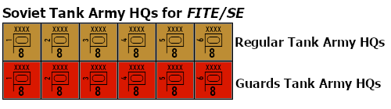
FITE/SE uses Soviet “army markers” based on the IDs of the historical armies as stacking aids. To save counters, the 1st, 3rd, and 5th are shown only as Guards, while the 2nd, 4th, and 6th are shown only as regulars. Here is the historical OB for the tank army HQs. There’s a reason for this OB: this article will present some optional rules for tank army HQs, which require the OB to be used.

Soviet Tank Army HQ Order of Battle

May II 42
Any MD:
1x Tank XXXX HQ 3
DISCUSSION: Unlike most Soviet units and formations, the Soviets did not form tank army HQs in numerical sequence. This possibly was intended to confuse German intelligence.

Jun I 42
Any MD:
1x Tank XXXX HQ 5

Jul II 42
Any MD:
1x Tank XXXX HQ 1

Aug I 42
Any MD:
1x Tank XXXX HQ 4

Jan II 42
Any MD:
1x Tank XXXX HQ 2

Mar II 43
Convert: 1x Tank XXXX HQ 5 to:
1x Tank XXXX HQ 5 (Gds)
DISCUSSION: The 5th Tank Army was effectively destroyed in the German counteroffensive of winter 1942/43. The field HQ of the tank army and its remnants remained on defense at the front, while the Soviets began forming its replacement, the 5th Guards Tank Army, in the rear areas. Actually, 5th Guards was formed on Feb II 43, but it was only in formation at this time. The Mar II 43 date represents when 5th Guards was sent into the strategic reserves. Technically, the Soviets briefly had two tank armies numbered “5”: the new 5th Guards and the remnants of the old 5th. In April, the field HQ of the 5th Tank Army was reorganized into the field HQ of a new infantry army, the 12th. This OB simplifies things by simply converting the 5th Tank Army to the 5th Guards Tank Army. There was no possibility that the Soviets would have rebuilt the regular 5th Tank Army to full strength once they decided to build the 5th Guards Tank Army.

May II 43
Convert: 1x Tank XXXX HQ 3 to:
1x Tank XXXX HQ 3 (Gds)
DISCUSSION: Actually, the 3rd Tank Army suffered very heavy losses during the German counteroffensive during the winter of 1942/43. With few tanks left in the army, the HQ was reorganized as an infantry army, the 57th. When the Soviets decided to reform the 3rd, they raised it as the 3rd Guards Tank Army. There was some continuity from the 3rd Tank to the 3rd Guards Tank. For example, P.S. Rybalko had commanded the 3rd Tank Army, became commander of the 57th Army when 3rd Tank was reorganized, and then was posted to be the commander of the 3rd Guards Tank.

Jan II 44
Any MD:
1x Tank XXXX HQ 6

Apr II 44
Convert: 1x Tank XXXX HQ 1 to:
1x Tank XXXX HQ 1 (Gds)

Sep I 44
Convert: 1x Tank XXXX HQ 6 to:
1x Tank XXXX HQ 6 (Gds)

Nov II 44
Convert: 1x Tank XXXX HQ 2 to:
1x Tank XXXX HQ 2 (Gds)

Mar II 45
Convert: 1x Tank XXXX HQ 4 to:
1x Tank XXXX HQ 4 (Gds)

Draft Optional and Experimental Rules for FITE/SE
These rules require use of the Tank Army HQ OB. These HQs cannot be used until they become available via the OB. A tank army HQ is a special type of headquarters rather than being a unit. It does move like a (c/m) headquarters unit (per SE Rule 14D). As a marker, it does not count towards stacking, does not participate in combat, does not need supply, etc. It can also be used to help with stacking like corps/army markers (SE Rule 8C). However, it only moves like a c/m headquarters units and cannot be freely repositioned like a corps/army marker.
These rules require use of the Tank Army HQ OB. These HQs cannot be used until they become available via the OB. A tank army HQ is a special type of c/m headquarters (see SE Rule 14D for headquarters rules). This means it moves like a c/m headquarters unit, has zero strength, requires supply, etc. However, it is not a front-line combat unit, so it does not count towards stacking and is never itself included in an attack. It is never included in the defense of a hex for combat or overrun purposes unless there are no units in the hex other than tank army HQs.
It can be used to help with stacking like a corps/army marker (SE Rule 8C). However, it only moves like a c/m headquarters units and cannot be freely repositioned like a corps/army marker.

