BUS114 Assessment 3 Employability Skills Audit & Action Plan

**Student Name:** <insert your name>  **Student Number:** <insert your student ID>

**IMPORTANT NOTE!**

* **Do not pdf this document**
* **Do not remove any elements - just fill it in 😊**

**Submission**

Upload this completed assessment template to EASTS.

**PART A – Employability Skills Audit**

1. Access the Employability Skills Audit from the link in the left-hand side menu on the BUS114 Interact2 site.
2. Complete all 9 skills categories and make sure you either SAVE each of your summaries via a screengrab AND/OR PDF.
3. Take a screenshot of each summary and paste them in below OR use the <insert object> option:
4. Click Insert>Object
5. >Create from File
6. Browse for the PDF you want to insert
7. Click Okay

# Communication Skills

<insert Skills Summary HERE (paste screen shot or insert PDF of Skill Summary)>

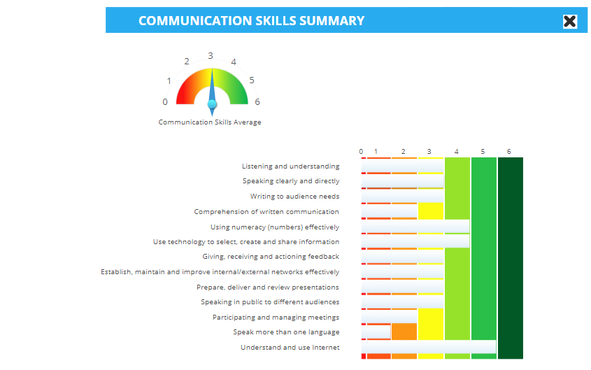

## **EVIDENCE**

I have demonstrated my communication skills by providing food orders and customer service on the phone or over the counter. This includes discussing the best deals and cooperating with customers.

# Teamwork and Leadership Skills

<insert Skills Summary HERE (paste screen shot or insert PDF of Skill Summary)>

## **EVIDENCE**

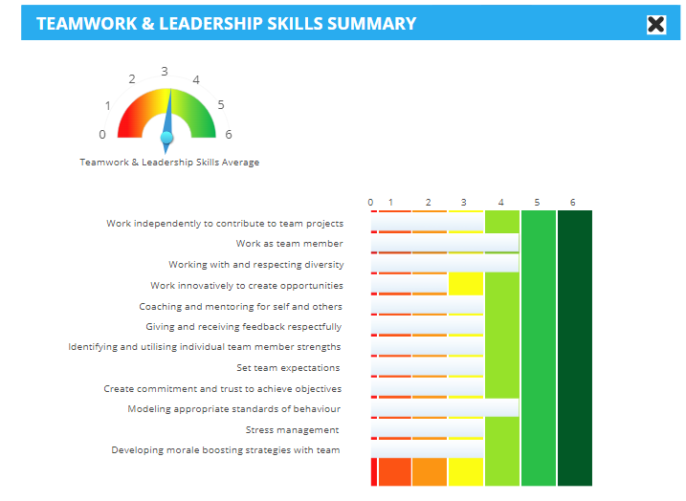I converse with team members at my work to get tasks such as food prep, cleaning and helping out with customer support.

# Personal skills, values and ethics

<insert Skills Summary HERE (paste screen shot or insert P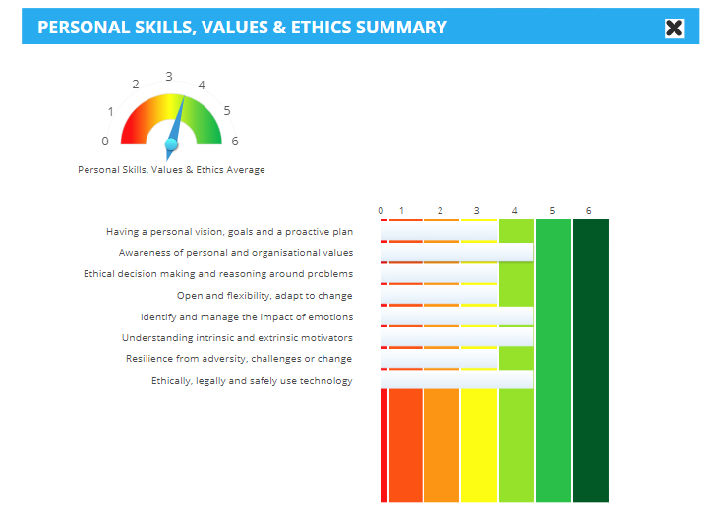DF of Skill Summary)>

## **EVIDENCE**

I avoid micromanaging and give positive feedback to team members, allowing good chemistry and work to be done without conflict.

# Problem solving skills

<insert Skills Summary HERE (paste screen shot or insert PDF of Skill Summary)>

## **EVIDENCE**

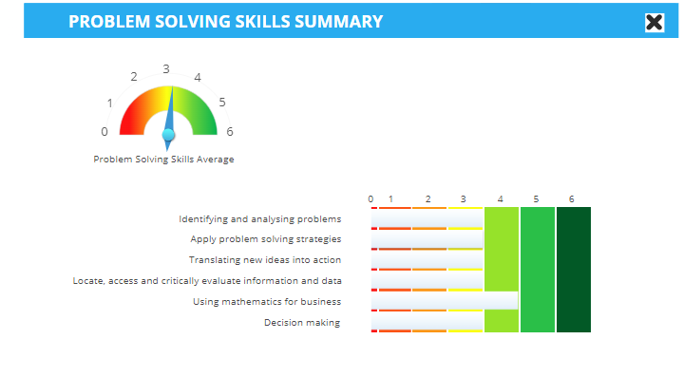I have made decisions to solve issues with customers. When customers get the wrong order I give them a refund or prepare another meal for them by the chefs. Sorting out prices for customers orders are done very quickly for me and has helped save time.

# Organising and management skills

<insert Skills Summary HERE (paste screen shot or insert PDF of Skill Summary)>

## **EVIDENCE**

I have helped in getting food preparation done on time for the chefs and have given customers a specific time to pick up their food orders.

# Learning, lifelong learning and career management

<insert Skills Summary HERE (paste screen shot or insert PDF of Skill Summary)>

## **EVIDENCE**

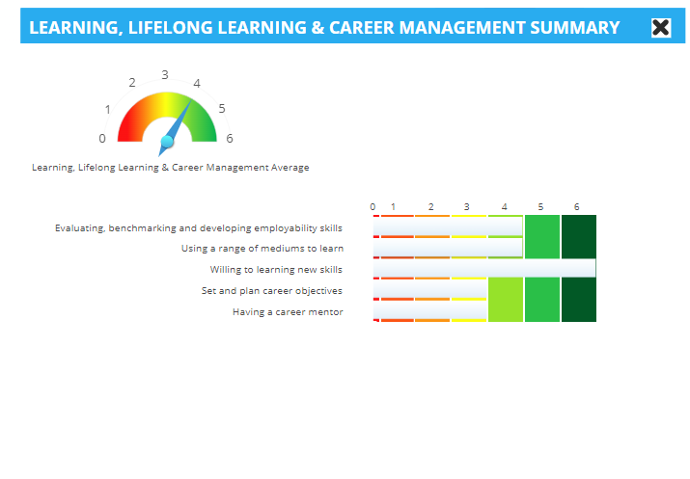I like to go out of my way to learn new things or ask for help when I need it. This includes asking for help from teachers during High School or current Charles Sturt University teachers.

# Technology skills

<insert Skills Summary HERE (paste screen shot or insert PDF of Skill Summary)>

## **EVIDENCE**

My technology skills regarding LibreOffice programs such as LibreOffice calc (similar to Microsoft Office Excel) is useful for mathematics. I can work around documentation issues regarding formatting, such as LibreOffice to Microsoft word, using 7zip instead of using WinZip and opening PDF files. I can find where printing errors can occur, though a bad internet connection or cancelling printing documents through “printers and scanners” settings.

# Cultural Competence skills

<insert Skills Summary HERE (paste screen shot or insert PDF of Skill Summary)>

## **EVIDENCE**

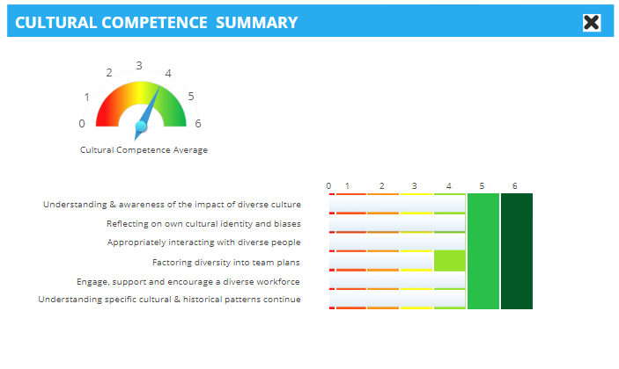For customers, at my job we support those with dietary needs such as celiac disease or we remove pork (ham, bacon, pepperoni and cabanossi) or others foods on pizzas to cater to customers needs.

# Environmental awareness

<insert Skills Summary HERE (paste screen shot or insert PDF of Skill Summary)>

## **EVIDENCE**

I keep rubbish and cardboard in separate bins for proper recycling at work and outside of work. Keeping power points off that aren't being used to save electricity or turning the air conditioner off when its not needed. Using the kitchen sink carefully to not waste water and using the dishwasher when it’s more benficial.

**PART B – Action Plan**

|  |
| --- |
| **My personal characteristics** |

Complete the table below with a short paragraph on each characteristic (HINT: look back at your reflection in your vision board assessment)

|  |  |
| --- | --- |
| **My values (things that are important to me, e.g. honest, hard-working)** | Having a stable life and job is important to me as it gives me a road map for how I can plan out my life schedule.  always wanting to learn as it expands my repertoire of skills, a greater perspective of the world around and more opportunities for the future.  Having sincerity for anybody as everyone has their own weaknesses but also strengths.  When working with others, having proper communication goes a long way in achieving desired outcomes. |
| **My interests** | I like to listen, learn and play music with my acoustic or electric guitar as I find it enjoyable  Going to the gym to achieve or maintain a healthy body and mind as it makes me feel great.  Using the internet to learn as I find it very satisfying to acquire knowledge and new skills.  Playing tennis or badminton is a sport that I can find delight in  Starting to learn Muay Thai for offensive and self defensive measures in the future.  When I have the time, I like to sit down and enjoy a bit of video games or board games. |
| **My proudest achievement** | My proudest achievement in my job has been my confidence to speak to customers over the phone and face to face as this skill can be used in a wide variety of jobs for communicating and has helped me converse with customers that need to wait one hour for their order due to an overwhelming amount of orders. |

**My personal characteristics**

|  |
| --- |
| **My education** |

Complete the table below with dot points about your education and achievements as appropriate

|  |  |
| --- | --- |
| **Completed subjects at Uni + results** | No completed subjects yet besides the CSU’s non-course subjects “Academic Integrity BJBS” and “Child Safety: Awareness and Mandatory Reporting of Child Sexual Assault and Abuse”. |
| **Current subjects at Uni** | BUS114: Contemporary Employability and Learning (S-BUS114_202390_W_D)  MGT100: Organisations and Management (S-MGT100_202390_B_D) |
| **Other completed certificates/statements of attainment** | None |

|  |
| --- |
| **My employment history** |

Complete the table with your employment history. (HINT: If you are not long out of school, detail your part-time jobs to date. If you have been working for some time, the past 10 years is enough)

|  |  |  |
| --- | --- | --- |
| **Organisation name** | **Position** | **Responsibilities and tasks undertaken (dot points)** |
| Dom's Pizza Parlour | Assistant Manager, Server | Cooperating with other workers for tasks, helping out customers |
|  |  |  |
|  |  |  |
|  |  |  |

|  |
| --- |
| **My volunteering, community and sporting involvement** |

Complete the table with your experience and achievements

|  |  |  |  |  |  |  |  |  |  |  |  |  |  |  |  |  |  |  |  |  |  |
| --- | --- | --- | --- | --- | --- | --- | --- | --- | --- | --- | --- | --- | --- | --- | --- | --- | --- | --- | --- | --- | --- |
| |  |  |  | | --- | --- | --- | | **Organisation name** | **Position** | **Responsibilities and tasks undertaken (dot points)** | |  |  |  | |  |  |  | |  |  |  | |  |  |  | |  |  |  | |  |  |  | |
|  |
|  |
|  |
|  |
|  |
|  |

|  |
| --- |
| **My Goals** |

Goals are things that you want to achieve in the future. Thinking about goals means that you will be prepared to study the subjects you like, work towards the occupation you want and keep your future options open.

Think about goals that relate to education/training and employment. For example, an education/training goal might be to hand all uni assignments in on time, and an employment goal might be to find a part-time job.

Think about why the goals you have made are important. For example, handing all Uni assignments in on time means you are developing time management skills (an important Employability skill), and working part-time helps you to develop a study-work-life balance.

Think about how long it will take you to achieve your goals. Some goals are short-term which means you can achieve them in a few weeks. Some goals are long-term which means it might take a year or more before you can achieve them.

## Goals I achieved LAST year

Complete with a brief description (dot points are fine if you prefer)

|  |
| --- |
| Making a start at CSU to open up future possibilities |
| Learnt new sport like skills including Muay Thai martial arts, roller skating and bush dancing to try new activities and get out of my comfort zone. |
| Learnt new programs such as canopy, xero and quickbooks in my spare time for accounting in the future. |

## My now and next goals

Thinking about the goals you want to achieve this year and next year, complete the table below:

|  |  |  |  |  |
| --- | --- | --- | --- | --- |
| **Year** | **What is my goal?** | **How will I do it?** | **Why is it important?** | **When will I do it by?** |
|  | To complete/obtain the “Undergraduate Certificate in Business” | I will complete all my assessments for the course. | For companies to see that I can put in the commitment and effort to work hard. | I will complete all sessions of my course by 25th October 2024. |
|  | To apply for an accounting course | I will apply for an accounting course through a university or Tafe course. | This will allow me to have the skills and confidence to work for a company with accounting needs. | I will apply once I obtain my undergraduate certificate in business. |
|  | To continue getting out of my comfort zone | This can be trying new activities I don’t usually do and going to new places. | I would like to have a better understanding of myself and what I’m capable of. | This goal is being worked on every day. |
|  | Find work placement | Get into contact with people in the industry through university or close relationships. | Having work placement will be beneficial for me in building my practical skills in the workforce and beneficial for the company to have extra help through my assistance. | As I am working through my undergraduate in business course currently and after I complete my course. |

|  |
| --- |
| **My career after graduation** |

Let’s now move to thinking about what you want to do in your career after graduation. Start by mapping out some information about your preferred career and then consider what employability skill development and career pathway you’ll need to have to get there.

## My preferred career

Complete with a brief description (dot points are fine if you prefer)

|  |  |
| --- | --- |
| **Preferred career** | **Accounting** |
| **Qualities required (check 'attributes' in: www.myfuture.edu.au, www.jobguide.deewr.gov.au)** | * **Numeracy literature** * **accounting software** * **assess economics** |
| **Responsibilities and tasks (check the 'skills' in www.myfuture.edu.au)** | * **Prepare financial statements** * **undertake audits** * **examine costs** |
| **Potential employers** | * **Boyce Chartered Accountants** * **RSM** * **Kurrajong (regional accounting)** |
| **Employment outlook (check out www.joboutlook.gov.au)** | * **Employment growth by industry for financial and insurance services on February 2023, Australia: 101,000** |
| **What area of specialisation do I** need **to choose next session/next year?** | * **ACC127 - Accounting and Financial Literacy** |
| **Which subjects do I need to enrol in next year (refer to Charles Sturt University Handbook https://handbook.csu.edu.au/ )** | * **2401AC01 - Bachelor of Accounting** |

|  |
| --- |
| **My attributes and employability skills** |

Complete with a brief description (dot points are fine if you prefer).

HINT: Attributes are personal characteristics such as personal presentation and motivation. Employability skills are covered in your Employability Skills Audit so please refer to your Skill summaries of those skills that you may need to develop further.

|  |  |  |  |
| --- | --- | --- | --- |
|  | **Description** | **Action (what do you need to do to develop these attributes and skills?)** | **Achievement date** |
| **Attribute 1** | **determination** | To remain calm and know that I can accomplish the task. | On going |
| **Attribute 2** | **enthusiasm** | To think positively, wanting to help people and learn. | On going |
| **Attribute 3** | **Adaptability** | Spend the time to focus and ask for help if I need a better time understanding the new concepts. | On going |
| **Employability skill 1** | **Learning, lifelong learning & career management** | Acquiring new practical fundamentals and knowledge alongside motivation, researching and asking for help to keep learning. Apply what I’ve learnt to my present job | On going |
| **Employability skill 2** | **Technology skills** | Watching videos to show a demonstration of how to improve the way technology is used such as using xero or LibreOffice Calc (Similar to Microsoft Excel) | On going |
| **Employability skill 3** | **Problem Solving skills** | Applying mathematics and noticing patterns with a keen eye to solve issues such as price costs. | On going |

|  |
| --- |
| **Dream big, what do you really want?** |

## My ideal ‘graduate’ job

|  |
| --- |
| Job title: Accountant (Accounting, industry) |
| Job advertisement: (this will lead me to accountant later) |

## Hmmmm... how can I get my ideal ‘graduate’ job?

Compare the skills you are required to have for your dream job to the skills you currently have (as indicated by your Employability Skills Audit results). Which skills do you have and need to successfully apply for the job AND also be able to actually 'do' the job?

|  |  |  |  |
| --- | --- | --- | --- |
| **Skill needed to do the job (as specified in the job ad)** | Skill 1: “Manage the end-to-end NDIS administration process, ensuring accurate and timely processing of claims and invoices”. | Skill 2: “Liaise and build healthy working relationships with a number of internal and external stakeholders to gather information and prepare claims submissions”. | Skill 3: “Generate and send invoices, monitor and follow up on outstanding payments and maintain an organised accounts receivable system”. |
| **I have this skill at the required level to do the job Y/N** | No | No | No |
| **I will have this skill by the time I graduate Y/N** | No | No | No |
| **What I could do to further develop this skill** | To look into future work placement to be able to understand and practice these skills. | Negotiating with people to demonstrate healthy relationships and find positive outcomes. | Have my own practice system of invoices, monitoring and outstanding payments done at home with my own resources or with resources tied from my job. |
| **What would someone with 10 years’ experience write about this skill in their job application?** | I have a great understanding of how to organise claims and invoices. | I can co-operate and build healthy relationships with internal and external stakeholders to successfully prepare claim submissions. | I can monitor invoices to be sent and have outstanding payments be organised through a systematic review. |
| **What kind of placement would develop the skills I need to get this type of graduate job (specify both the kind of placement and the type of organisation)** | To process claims and invoices, I could do a temporary placement for Boyce Chartered Accountants. | To build relationships with stakeholders and prepare claims, I could do a temporary-to-hire placement at RSM. | For organising invoices and outstanding payments, I could do temporary placement at Dawson & Partners. |

|  |
| --- |
| **My Action plan for graduation** |

Start planning! Now you’ve thought more about your career and visualised your dream ‘graduate’ job, use the template below to develop an Action Plan of how you will work on develop the employability skills you want to develop between now and when you graduate. In your action steps consider:

* ​​​​​​​What kind of work would you like to do your work placement? Do you have a specific company in mind? What can you do to start working this out and lining this up? (Remember to consider Supply Nation as well as your own personal and professional connections)
* What else can you do to further develop your Employability Skills? Consider volunteering and/or mentoring/tutoring through Charles Sturt University, joining the Student Representative Council, starting STRIVE.

## Employment goals

Complete with a brief description (dot points are fine if you prefer).

|  |  |  |  |
| --- | --- | --- | --- |
| **What is my employability skill goal? (use ‘smart’)** | **How will I develop this employability skill?** | **Why did I choose this employability skill?** | **When will I do it by and how will I know I've achieved my goal?** |
| **Learning, lifelong learning & career management**  **Specific:** I will define what I am learning in the work of accounting  **Measurable:** I will create a plan and new methods of management to overcome the challenges of learning  **Achievable:** This will be obtainable through my ability to learn  **Realistic:** I will gain a better understanding of accounting with incentive through this employability skill.  **Timely:** I will have this skill when I go for an accounting work placement. | To have a schedule set out with motivation and focus to develop this skill alongside studying the fundamentals of what makes accounting from the beginning topics of financial statements through text books and learning online. | By demonstrating my ability to learn through motivation I will be seen as an active worker that can be a benefit for a company. | I will have shown  positive growth  throughout  my work placement  and outside of  work |
| **Technology skills**  **Specific:** I will enhance my skills with technology such as computers and programs.  **Measurable:** I will research new ways of using programs for accounting.  **Achievable:** I can improve technology skills with the right resources, starting off with a computer.  **Realistic:** I can manage technology, **t**his will help me for accounting and employers will notice.  **Timely:** I will continually work on technology skills as it is always updating over time and looking forward to the future. | I will keep on enhancing and maintaining my technology skills by applying myself everyday to using xero and LibreOffice Calc for accounting. | Having technology skills is vital for applying in any accounting related job as it is the best way of writing out and exchanging information regarding financial statements. | My journey with  technology skills  will continue  as technology  is updating all the  time. I can finish my  goal of understanding  it within  one month. |
| **Problem Solving skills**  **Specific:** I will find ways of solving mathematical problems  **Measurable:** I will look up examples of ways to solve problems in accounting  **Achievable:** I can solve mathematical problems with the materials and information that is accessed through text books and the internet  **Realistic:** Not all problems I can solve by myself easily but I will find patterns to solve the problem or ask for help.  **Timely:** problem solving will be accomplished given the appropriate time, ranging from a few hours to days. | To improve my skills in problem solving, I can look up references through text books or online. | There is still a need to learn how to problem solve in accounting despite technology, whether that be through checking correct mathematics inputs through clients and workers or business knowledge. | To reach my goal  In problem solving  Skills, I will look up  Examples and solve  small problems  within a time frame,  one problem each day  Work place problems  Could take within a day  or longer |

|  |
| --- |
| **One last reflection…** |

Complete with a brief description (dot points are fine if you prefer).

The purpose of this question is to help you think about what you’ve learned in this subject. Remember, there’s no right or wrong in reflection, rather the most valuable answer is the one that honestly and accurately captures your thoughts now, while tracking any changes in your thinking over time.

|  |  |
| --- | --- |
| **At the start of this subject, I thought employability skills were?** | **I thought that employability skills mainly focused on just the skills needed to fit a criteria for a job, an example would be knowing how to use Xero for accounting.** |
| **How have your views on employability skills grown or changed?** | **Employability skills have helped me gain a better understanding of ways to benefit more into the workforce such personal values of open-mindedness and communication to levitate customers concerns when dealing with a problem.** |
| **What has helped you the most to develop a clearer idea of what career/job you want after graduation?** | **Studying what I like and what I don’t like to assess what type of job I would like for the future, I enjoy mathematics and business so I am working on becoming an accountant.** |
| **OPTIONAL RECOMMENDATION - If I could add, change or remove something in this subject, I would...?** | **This subject could add a work place topic about finding contempt in a job and learning when, why and how to make a career change when you have been in the same work force for so long.** |

**NOTE: To save time, remember to save this Assessment somewhere as you may like to refer to it in BUS223 where we will build on your career plan!**

**YOUR GRADE AND FEEDBACK**

**Marking Criteria** (this will be used by your marker and returned to you via EASTS – do not edit this section)

|  |  |  |  |  |  |  |  |  |  |  |  |  |  |
| --- | --- | --- | --- | --- | --- | --- | --- | --- | --- | --- | --- | --- | --- |
| **Criteria** | **HD** | **DI** | | | | **CR** | | | **PS** | | | | **FL** |
| **Part A – Complete your Employability Skills Audit** (10 marks)  Step 1 - Complete the Employability Skills Audit | All employability skill categories and sub-categories of the Employability Skills Audit have been rated. | | | | | | | | | | | Does not meet the standard of a PASS - incomplete or not submitted | |
| **Part A – Complete your Employability Skills Audit** (15 marks)  Step 2 - Justify your overall position with evidence (it may be a qualification, an award, previous experience, or any other relevant activity which demonstrates the level you have chosen). | The evidence solidly justifies the scoring. Detailed, highly convincing evidence  strongly connected to the sub-categories and overall audit was provided.  The task shows high self-awareness, insight, personal reflection and exceptional engagement with the task. | | The evidence well justifies the scoring. Detailed, convincing evidence  well connected to the sub-categories and overall audit was provided.  The task shows self-awareness, personal reflection and high engagement with the task. | | | | The evidence justifies the scoring. Quite useful evidence overall with an attempt connections with the sub categories was provided.  The task shows good awareness, reflection and engagement with the task. | | | | The evidence largely accounts for the scoring. Useful evidence which connects only to the audit overall.  The task shows engagement with the task and/or may be limited in detail. | Does not meet the standard of a PASS - incomplete or not submitted | |
| **Part B complete the Action Plan** (5 marks)  Step 1 - Find a job. | An image and link for an advertised highly suitable graduation job has been provided in the Assessment template. | | | An image and link for an advertised well suitable graduation job has been provided in the Assessment template. | | | | An image and link for an advertised suitable graduation job has been provided in the Assessment template. | | An image and link for an advertised graduation job has been provided in the Assessment template. | | | Does not meet the standard of a PASS - incomplete or not submitted. |
| **Part B complete the Action Plan** (20 marks)  Step 2 - Complete your Action Plan | Current Employability Skills are accurately and insightfully compared to skills required to do the graduate job. Areas of development are meticulously determined.  Highly realistic and well-articulated Action Plan utilises the SMART goals effectively and precisely determines and prioritises the actions required to achieve career and job goals. The plan expertly takes into consideration the areas of development identified in the previous step.  Solid reasons are provided to justify estimates.  Simple to understand plan yet expertly based on strongly valid foundations which expertly meet SMART conditions.  Persuasively convincing action plan that the stated goals could be successfully achieved. | | | | Current Employability Skills are proficiently compared to skills required to do the graduate job. Areas of development are well-determined.  Realistic and proficient Action Plan utilises the SMART goals effectively to chart career and job goals. SMART plan skilfully formulates the actions required to achieve the goals. The plan proficiently takes into consideration the areas of development identified in the previous step.  Reasons are provided to justify estimates.  Plan is clear and proficiently based on valid foundations which proficiently meet SMART conditions.  Convincing action plan that the stated goals could be successfully achieved. | | | Current Employability Skills are competently compared to skills required to do the graduate job. Areas of development are explained.  Realistic and competent Action Plan utilises the SMART goals to explain career and job goals. SMART plan competently classified the actions required to achieve the goals. The plan competently takes into consideration the areas of development identified in the previous step.  Estimates are given but only partially justified.  Plan is understandable, evident and competently based on valid foundations which meet SMART conditions.  Action plan could successfully achieve the stated goals according to the plan. | | Current Employability Skills are adequately compared to skills required to do the graduate job. Areas of development are identified.  Somewhat realistic Action Plan utilises the SMART goals to loosely identify career and job goals. SMART plans adequately named the actions required to achieve the goals. The plan has a limited connection to the areas of development identified in the previous step.  Estimates are given but not justified.  Plan is limited although adequately based on valid foundations to adequately meet SMART conditions.  Action plan needs further development to successfully achieve the stated goals according to the existing plan. | | | Does not meet the standard of a PASS - incomplete or not submitted. |

**Comments: /50**