File was originally created on Apache OpenOffice 4.1.14
- OpenOffice 4.1.14
numbering style: Nummerierung 1 (123)
aligned at -0,7 cm
- 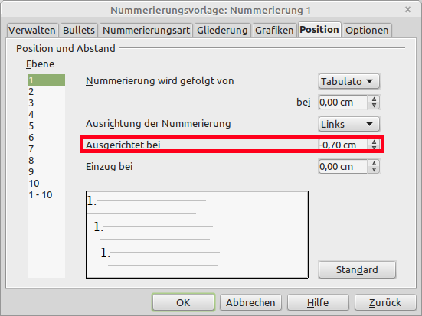
- Until this paragraph: paragraph style default
- From here: new paragraph style „TextkörperMitNumVorlage1Verbunden“ (text body resp. body text) connected to numbering style
text...
- LibreOffice 7.6.4.1 not more able to display negative alignment:
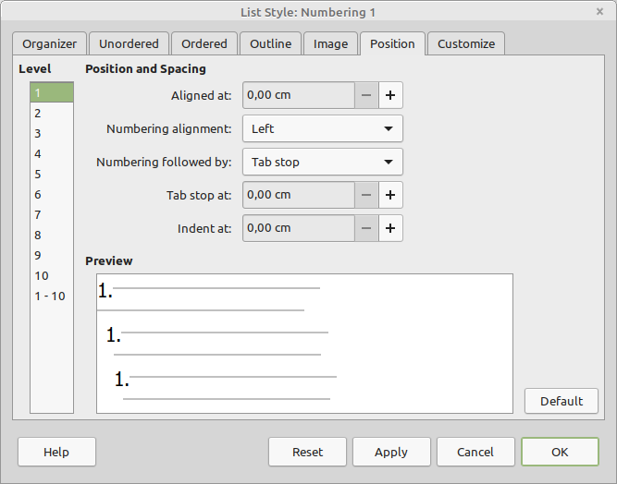
- Negative indent is continued, but is not more adaptable – negative values are automatically set to 0 → regression?
- text

