How to to run mail merge with dependent text tables

Preface
Printing a form letter from the regular user interface and letting a macro program intercept this process seems to be impossible. However, it is possible to set up your own mail merge process independently from the built-in user interface. Within this program, every instance of a form letter is interceptable. I wrote a Python macro that allows us to set up form letters with extra tables to be filled with row sets from parameter queries dependent on the form letter’s row set. For example, each instance of your invoice form letter can have its own table of invoice items.
The ability to do so depends on your skills in SQL. Apart from a mail merge query, you need one parameter query for each dependent mail merge table. It is your obligation to take care of consistent record sets. I don’t have the time and patience to build a decent user interface for this program. All the connection details are defined by an invisible input form. All the extra options regarding printers, files or emails are stored as custom properties of your form letter (menu:File>Properties… tab “Custom Properties”). All the settings are stored. Next time a click on a button produces the next set of form letters with tables.

Creating a Form Named “MailMerge_Master”
Turn on form design mode, get the form navigator and add the row set of your mail merge to a form named “MailMerge_Master”. No need to add any visible form controls.
Choose source type “Table” and a table name or choose source type “Query” with a query name. “Analyse SQL command” should be on in most cases. It should be the same row set as used by your mail merge fields. On the “General” tab of this dialog, it is important that this particular form is named “MailMerge_Master”.
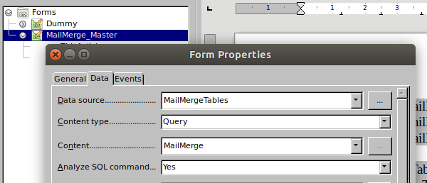Figure 1: Data properties of form "MailMerge_Master" with form navigator in background.

Create Dependent Target Tables
Having a form letter with database fields, add one or more tables you want to fill with row sets from the same data source as your form letter. Such table starts with 2 rows, one row for the column headers and a second row as a place holder for the first row of data. Format the 2 rows any way you want. Write some dummy data into the second row. The second row is just a format template for the subsequent rows.

Connect Target Tables With Parameter Queries
For each dependent target table add a parameter query to your Base document. In many cases such a parameter query would look like this one:
SELECT "Article Number","Article Name","Quantity","Price", "Quantity" * "Price" AS "Amount"
FROM "Some_Tables"
WHERE "InvoiceID" = :paramID
selecting some columns from some tables where the invoice number matches the given parameter.
Your parameter query should fulfill the following preconditions:
1. The column order matches the column order of the prepared target table. Regarding the column count, additional columns exceeding the column count of the target table will be ignored. Exceeding columns in the target table remain blank.
2. The given parameter(s) should select one distinct mail merge row (one distinct invoice for example). If this is not the case, your target table gets rows merged from multiple instances of the master row set (i.e. articles from more than one invoice).
Back to your Writer document, right-click the “MailMerge_Master” form in the form navigator and add a new hidden control. A hidden form control is a place to store configuration data for macro programs. A hidden control consists of 3 text values:
1. Name: We name our hidden control after the target table you want to fill.
2. Value: Enter the name of your parameter query.
3. Additional info: Enter the name(s) of the mail merge columns(s) to substitute the parameter(s) of your query. Separate multiple column names with semicolon.
The following 2 illustrations show the setup of my test document. The first example has one parameter whereas the second example has 3 parameters.
The dependent table “Tbl_Articles” is filled by parameter query “Param_Articles” having a single parameter to be substituted by column “INVID” of form “MailMerge_Master”.
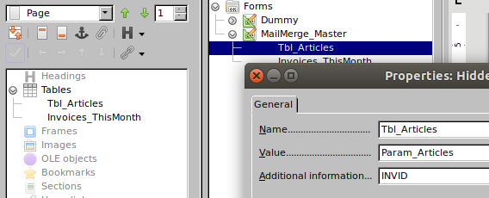Figure 2: Properties of a hidden control “Tbl_Articles” attached to form "MailMerge_Master" in front of the document navigator and the form navigator.
The second dependent table “Invoices_ThisMonth” is filled by parameter query “Param_Months” having 3 parameters to be substituted by the specified 3 columns “Customer ID”, “Year” and “Month” of form “MailMerge_Master”.
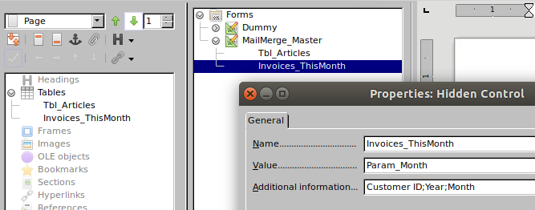Figure 3: Properties of a hiden control “Invoices_ThisMonth” attached to form "MailMerge_Master" in front of the document navigator and the form navigator.
We enter the names of the substituting columns in the master query without bothering about the names of the substituted parameters in the slave query.

Issue: How to find out the right order of columns according to the order of parameters if the parameter names don’t matter?
Column names in wrong order yield error messages or wrong table contents. Looking at the SQL code of my parameter query, the order of appearance is: "INVOICE"."CID" = :pCID AND YEAR( "TS" ) = :pYear AND MONTH( "TS" ) = :pMonth. The parameters appear in the order of :pCID, :pYear and :pMonth, and therefore the correct order of substituting master columns entered into the additional info box is [Customer ID;Year;Month].

The Gory Details of Print-Out
A form letter can be sent to a printer, stored as one file, as many files (one file per letter) or as email attachments. Each of the 3 output types printer, file(s) and mail implies another set of options. For my mail merge program these options are stored in custom file properties (menu:File>Properties… tab “Custom Information”) as described in the following 4 tables.
If you specify SaveAsSingleFile=Yes and SaveFilter=writer_pdf_Export everything goes to a single PDF mydoc.pdf, next time to mydoc0.pdf.

General options for all output types
Name | Type | Values | Description
OutputType | Number | 1, 2, 3 or 4 | printer (1), files (2) or email (3)  default=4 (new document)
Filter | String | An SQL condition like  NOT "EMAIL" IS NULL | Optional Useful for ad-hoc filtering without setting up new queries.

OutputType 4 (Default)
Ouput Type 4 generates a single, unsaved output document and loads it into a Window. “Filter” is the only additional option.

Options For Printers (OutputType 1)
I did not test all these options. On my home printer “DuplexMode” 2 and 3 did not make any difference.
Name | Type | Values | Description
SinglePrintJobs | Yes/No | Default = No | Each form letter instance becomes one job in the printer’s job queue
CopyCount | Number | Default = 1
FileName | String |  | Only if you print to a file printer
Collate | Yes/No | Default = No | advises the printer to collate the pages of the copies.
Pages | String | Default: empty (print all) | “1” or “1,3,5” or “1-5”
Wait | Yes/No | Default = Yes | Synchronous print-out
DuplexMode | Number | 0,1,2 or 3 | Leave it up to the printer (0), No (1), long edge binding (2), short edge binding (3)
PrinterName | String | Default: Your default printer | Name of your printer as shown in the printer dialog

Options For File Output (OutputType 2)
The mail merge feature will not overwrite any files. If file “foo_123 pdf” exists, any new file with the same name will be named “foo_1231.pdf” and the next one “foo_1232.pdf” and so on.
Name | Type | Values | Description
SaveAsSingleFile | Yes/No | Default = No | If no, every form letter instance is written into a separate file
FileNameFromColumn | Yes/No | Default = No | Determines whether file names of created files are generated using the content of a database column. If Yes, the column must not be numeric. Convert any ID numbers to text, e.g. by SQL CAST or by concatenation. Otherwise the mail merge fails with an unspecific error message.
FileNamePrefix | String |  | Either a column name if the previous option is Yes. Or a literal file name prefix.
OutputURL | String | Default: Same as document directory | URL of a directory like file:///path/
SaveFilter | String | Writer output (*.odt) when missing | Some useful filter names:  writer8 (default)  writer_pdf_Export  writer8_template  OpenDocument Text Flat XML  MS Word 2007 XML
SaveFilterOptions | String | Undocumented | Additional options for certain file types

Options For Email Output (OutputType 3)
I did not test every possible combination. Mails with PDF-Attachments work pretty well. I disabled BlindCopiesTo and CopiesTo because of numerous difficulties.
Name | Type | Values | Description
AddressFromColumn | String | Name of database column with mail addresses | Mandatory.
AttachmentFilter | String | Default is Writer output (*.odt).  Recommended: PDF | Some useful filter names:  writer 8 (default)  writer_pdf_Export  writer8_template  OpenDocument Text Flat XML  MS Word 2007 XML
AttachmentName | String |  | Only if"SendAsAttachment" is set to Yes.
BlindCopiesTo | []String | Ignored, fails with Python, faulty with StarBasic | Mail addresses separated by semicolon
CopiesTo | []String | Ignored, fails with Python, faulty with StarBasic | Mail addresses separated by semicolon
InServerPassword | String | Ignored | Set up in the LibreOffice Writer options
MailBody | String
OutServerPassword | String | Ignored | Set up in the LibreOffice Writer options
SendAsAttachment | Yes/No | Default: False | determines that the created mail merge document is sent as attachment.
SendAsHTML | Yes/No | Evaluated only if SendAsAttachment=No | determines that the created mail merge document is sent as body in HTML format.
Subject | String

Installing the Python script
This is more straight forward than using it. Download a Writer document and click the install button.
The script offers 3 callable routines in the macro dialogs under MyMacros>pyWriter>MailMergeTables:
1. start_MailMerge runs the preconfigured mail merge with or without dependent tables.
2. fill_MasterTables is a byproduct. It fills all Writer tables having an equally named master form with the form's row set. No mail merge involved.
3. clear_MyTables clears all affected text tables having an equally named master form or having an equally named hidden control under the "MailMerge_Master" form. The routine deletes all table rows below the second row. Text cells in the second row are cleared. Numeric cells are filled with zeroes because LibreOffice would remove the number formatting otherwise.

