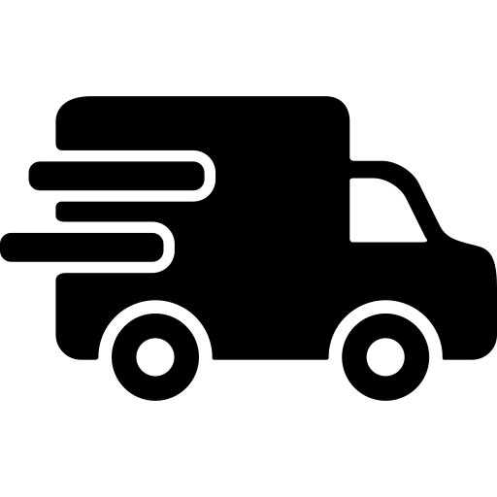
DELIVERIES
& COLLECTIONS
Please pick up or drop off packages in the porch.
The door is unlocked and opens outwards
If you need a signature please try No 8 ☺
Many Thanks for your help.
John & Kirsty

