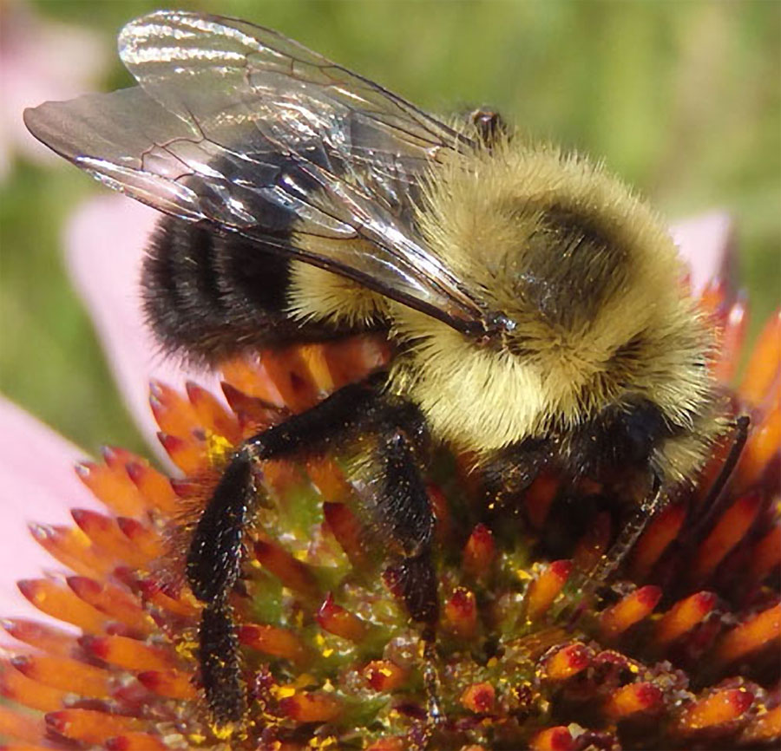

Bumblebee, with permission [Mark Brown](http://www.pbase.com/markb249)

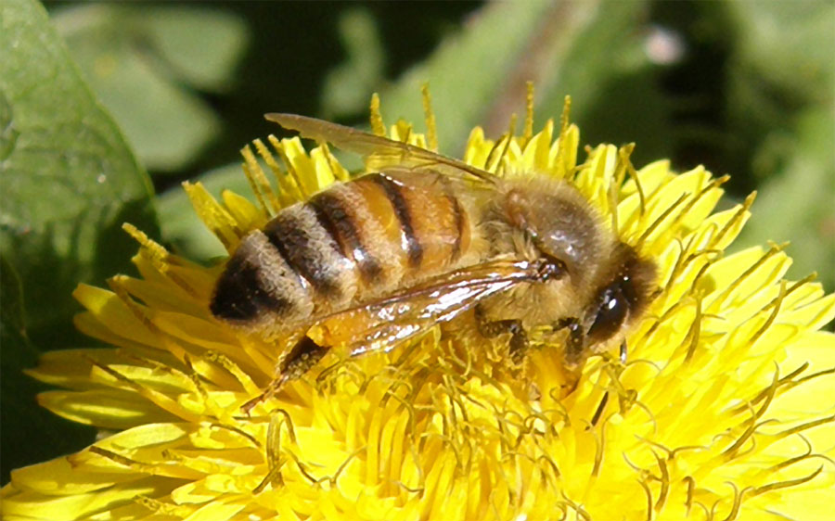

Honey bee, with permission C Fred Zeillemaker