Why Do We See Different Colours?
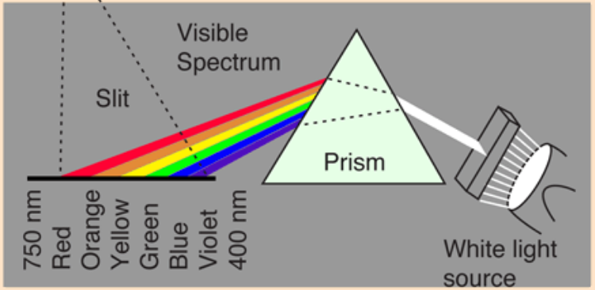

- Look at the photograph.
How many colours make up white light?

- What colour do you see if you place a blue filter in front of the light?
- What colour do you see if you a yellow filter in front of the light?
- What colour do you see if you place both blue and yellow filters in front of the light?

- Part of the MJC logo is yellow.
  - From your experiment, which colour is being reflected from the yellow material?
  - Which colours are being absorbed by the yellow material?
  - Predict what colour will be seen if you shine blue light onto the yellow material.

>>>>>>>>>>>>>>>>>>>>>>>>>>>>>>>>>>>>>>>>>>>>>>>>>>>>>>>>>>>>>>>>>>>>>

- What was the aim of the experiment that Paige performed?
- What did Paige measure or observe in the experiment?
- Write a conclusion to the experiment.
(A conclusion is the answer to the aim).

>>>>>>>>>>>>>>>>>>>>>>>>>>>>>>>>>>>>>>>>>>>>>>>>>>>>>>>>>>>>>>>>>>>>>

- Go to this youtube video:
https://www.youtube.com/watch?v=AskAQwOBvhc

Apart from some being absorbed and others being reflected, what else determines the perception of colour?

- Use your laptop to find out what colour blindness is
- How many people are affected by colour blindness?
- What causes colour blindness?

>>>>>>>>>>>>>>>>>>>>>>>>>>>>>>>>>>>>>>>>>>>>>>>>>>>>>>>>>>>>>>>>>>>>>

