8 Carburation and Induction
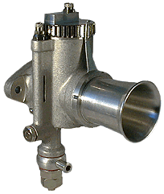
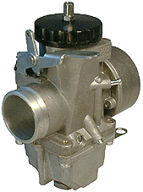
Lorem ipsum odor amet, consectetuer adipiscing elit. Eget eget orci lacus hendrerit ridiculus maecenas neque facilisi. Scelerisque leo sollicitudin ullamcorper per ultrices viverra per venenatis erat. Eu ridiculus fringilla ligula; tempus sagittis facilisis. Vel sapien ullamcorper ridiculus massa vel blandit. Blandit adipiscing parturient mus senectus volutpat sem laoreet libero. Finibus vivamus imperdiet class lacinia porta tellus purus interdum? Risus cras cras imperdiet et montes sociosqu nascetur urna.
Vehicula cubilia id varius phasellus sagittis mollis. Feugiat purus dis ante faucibus cursus aptent. Etiam dictum aptent elementum litora ridiculus facilisi blandit nullam. Felis lacus pulvinar nullam mauris platea torquent arcu. Ornare curabitur congue ipsum rutrum conubia vel conubia ultrices. Viverra tellus nibh nisl urna non augue. Dui diam feugiat mollis metus conubia accumsan sed inceptos mi. Platea nisi augue duis enim rutrum hac parturient blandit netus. Pharetra convallis dignissim, potenti tortor volutpat potenti dui.
Sed justo commodo auctor viverra dictum habitasse. Nulla volutpat fames vel augue condimentum. Molestie placerat gravida libero imperdiet penatibus nascetur vulputate. Malesuada scelerisque sit odio fusce, montes curae? Commodo curae viverra platea ridiculus tellus egestas ligula. Condimentum eu varius sed nunc turpis in leo. Montes magnis tincidunt pharetra class, imperdiet tempus nullam. Magna magna mollis inceptos suspendisse elementum. Vestibulum eget et nascetur magna donec eros habitant consequat. Mattis augue tristique nulla nam in ex.
Dis mollis nisl ligula per feugiat pharetra. Ultricies montes torquent molestie aenean feugiat. Vehicula quisque leo platea dui litora a. Parturient praesent nibh dui quisque quisque. Pulvinar donec rhoncus donec nibh leo sapien. Suscipit aliquet ultricies torquent suscipit luctus convallis neque curae. Eget mus pulvinar in placerat phasellus risus. Scelerisque et facilisi phasellus mollis aenean eros. Tristique senectus risus ex cras, semper imperdiet nec habitant vulputate?
Congue cursus conubia porttitor parturient quam. Iaculis felis phasellus interdum per maecenas natoque commodo. Laoreet ligula volutpat nam metus egestas pretium. Id ligula class mattis pharetra vehicula hendrerit platea pretium. Phasellus tellus placerat justo, ut tincidunt metus adipiscing. Aenean per feugiat dignissim varius eros. Vivamus sem sed nulla suspendisse venenatis nam eget scelerisque. Quisque tristique pellentesque tempus vestibulum ultrices mauris integer. Faucibus ante netus massa donec eget volutpat.

Lorem ipsum odor amet, consectetuer adipiscing elit. Eget eget orci lacus hendrerit ridiculus maecenas neque facilisi. Scelerisque leo sollicitudin ullamcorper per ultrices viverra per venenatis erat. Eu ridiculus fringilla ligula; tempus sagittis facilisis. Vel sapien ullamcorper ridiculus massa vel blandit. Blandit adipiscing parturient mus senectus volutpat sem laoreet libero. Finibus vivamus imperdiet class lacinia porta tellus purus interdum? Risus cras cras imperdiet et montes sociosqu nascetur urna.
Vehicula cubilia id varius phasellus sagittis mollis. Feugiat purus dis ante faucibus cursus aptent. Etiam dictum aptent elementum litora ridiculus facilisi blandit nullam. Felis lacus pulvinar nullam mauris platea torquent arcu. Ornare curabitur congue ipsum rutrum conubia vel conubia ultrices. Viverra tellus nibh nisl urna non augue. Dui diam feugiat mollis metus conubia accumsan sed inceptos mi. Platea nisi augue duis enim rutrum hac parturient blandit netus. Pharetra convallis dignissim, potenti tortor volutpat potenti dui.
Sed justo commodo auctor viverra dictum habitasse. Nulla volutpat fames vel augue condimentum. Molestie placerat gravida libero imperdiet penatibus nascetur vulputate. Malesuada scelerisque sit odio fusce, montes curae? Commodo curae viverra platea ridiculus tellus egestas ligula. Condimentum eu varius sed nunc turpis in leo. Montes magnis tincidunt pharetra class, imperdiet tempus nullam. Magna magna mollis inceptos suspendisse elementum. Vestibulum eget et nascetur magna donec eros habitant consequat. Mattis augue tristique nulla nam in ex.
Dis mollis nisl ligula per feugiat pharetra. Ultricies montes torquent molestie aenean feugiat. Vehicula quisque leo platea dui litora a. Parturient praesent nibh dui quisque quisque. Pulvinar donec rhoncus donec nibh leo sapien. Suscipit aliquet ultricies torquent suscipit luctus convallis neque curae. Eget mus pulvinar in placerat phasellus risus. Scelerisque et facilisi phasellus mollis aenean eros. Tristique senectus risus ex cras, semper imperdiet nec habitant vulputate?
Congue cursus conubia porttitor parturient quam. Iaculis felis phasellus interdum per maecenas natoque commodo. Laoreet ligula volutpat nam metus egestas pretium. Id ligula class mattis pharetra vehicula hendrerit platea pretium. Phasellus tellus placerat justo, ut tincidunt metus adipiscing. Aenean per feugiat dignissim varius eros. Vivamus sem sed nulla suspendisse venenatis nam eget scelerisque. Quisque tristique pellentesque tempus vestibulum ultrices mauris integer. Faucibus ante netus massa donec eget volutpat.
Lorem ipsum odor amet, consectetuer adipiscing elit. Eget eget orci lacus hendrerit ridiculus maecenas neque facilisi. Scelerisque leo sollicitudin ullamcorper per ultrices viverra per venenatis erat. Eu ridiculus fringilla ligula; tempus sagittis facilisis. Vel sapien ullamcorper ridiculus massa vel blandit. Blandit adipiscing parturient mus senectus volutpat sem laoreet libero. Finibus vivamus imperdiet class lacinia porta tellus purus interdum? Risus cras cras imperdiet et montes sociosqu nascetur urna.
Vehicula cubilia id varius phasellus sagittis mollis. Feugiat purus dis ante faucibus cursus aptent. Etiam dictum aptent elementum litora ridiculus facilisi blandit nullam. Felis lacus pulvinar nullam mauris platea torquent arcu. Ornare curabitur congue ipsum rutrum conubia vel conubia ultrices. Viverra tellus nibh nisl urna non augue. Dui diam feugiat mollis metus conubia accumsan sed inceptos mi. Platea nisi augue duis enim rutrum hac parturient blandit netus. Pharetra convallis dignissim, potenti tortor volutpat potenti dui.
Sed justo commodo auctor viverra dictum habitasse. Nulla volutpat fames vel augue condimentum. Molestie placerat gravida libero imperdiet penatibus nascetur vulputate. Malesuada scelerisque sit odio fusce, montes curae? Commodo curae viverra platea ridiculus tellus egestas ligula. Condimentum eu varius sed nunc turpis in leo. Montes magnis tincidunt pharetra class, imperdiet tempus nullam. Magna magna mollis inceptos suspendisse elementum. Vestibulum eget et nascetur magna donec eros habitant consequat. Mattis augue tristique nulla nam in ex.
Dis mollis nisl ligula per feugiat pharetra. Ultricies montes torquent molestie aenean feugiat. Vehicula quisque leo platea dui litora a. Parturient praesent nibh dui quisque quisque. Pulvinar donec rhoncus donec nibh leo sapien. Suscipit aliquet ultricies torquent suscipit luctus convallis neque curae. Eget mus pulvinar in placerat phasellus risus. Scelerisque et facilisi phasellus mollis aenean eros. Tristique senectus risus ex cras, semper imperdiet nec habitant vulputate?
Congue cursus conubia porttitor parturient quam. Iaculis felis phasellus interdum per maecenas natoque commodo. Laoreet ligula volutpat nam metus egestas pretium. Id ligula class mattis pharetra vehicula hendrerit platea pretium. Phasellus tellus placerat justo, ut tincidunt metus adipiscing. Aenean per feugiat dignissim varius eros. Vivamus sem sed nulla suspendisse venenatis nam eget scelerisque. Quisque tristique pellentesque tempus vestibulum ultrices mauris integer. Faucibus ante netus massa donec eget volutpat.
Lorem ipsum odor amet, consectetuer adipiscing elit. Eget eget orci lacus hendrerit ridiculus maecenas neque facilisi. Scelerisque leo sollicitudin ullamcorper per ultrices viverra per venenatis erat. Eu ridiculus fringilla ligula; tempus sagittis facilisis. Vel sapien ullamcorper ridiculus massa vel blandit. Blandit adipiscing parturient mus senectus volutpat sem laoreet libero. Finibus vivamus imperdiet class lacinia porta tellus purus interdum? Risus cras cras imperdiet et montes sociosqu nascetur urna.
Vehicula cubilia id varius phasellus sagittis mollis. Feugiat purus dis ante faucibus cursus aptent. Etiam dictum aptent elementum litora ridiculus facilisi blandit nullam. Felis lacus pulvinar nullam mauris platea torquent arcu. Ornare curabitur congue ipsum rutrum conubia vel conubia ultrices. Viverra tellus nibh nisl urna non augue. Dui diam feugiat mollis metus conubia accumsan sed inceptos mi. Platea nisi augue duis enim rutrum hac parturient blandit netus. Pharetra convallis dignissim, potenti tortor volutpat potenti dui.
Sed justo commodo auctor viverra dictum habitasse. Nulla volutpat fames vel augue condimentum. Molestie placerat gravida libero imperdiet penatibus nascetur vulputate. Malesuada scelerisque sit odio fusce, montes curae? Commodo curae viverra platea ridiculus tellus egestas ligula. Condimentum eu varius sed nunc turpis in leo. Montes magnis tincidunt pharetra class, imperdiet tempus nullam. Magna magna mollis inceptos suspendisse elementum. Vestibulum eget et nascetur magna donec eros habitant consequat. Mattis augue tristique nulla nam in ex.
Dis mollis nisl ligula per feugiat pharetra. Ultricies montes torquent molestie aenean feugiat. Vehicula quisque leo platea dui litora a. Parturient praesent nibh dui quisque quisque. Pulvinar donec rhoncus donec nibh leo sapien. Suscipit aliquet ultricies torquent suscipit luctus convallis neque curae. Eget mus pulvinar in placerat phasellus risus. Scelerisque et facilisi phasellus mollis aenean eros. Tristique senectus risus ex cras, semper imperdiet nec habitant vulputate?
Congue cursus conubia porttitor parturient quam. Iaculis felis phasellus interdum per maecenas natoque commodo. Laoreet ligula volutpat nam metus egestas pretium. Id ligula class mattis pharetra vehicula hendrerit platea pretium. Phasellus tellus placerat justo, ut tincidunt metus adipiscing. Aenean per feugiat dignissim varius eros. Vivamus sem sed nulla suspendisse venenatis nam eget scelerisque. Quisque tristique pellentesque tempus vestibulum ultrices mauris integer. Faucibus ante netus massa donec eget volutpat.
Lorem ipsum odor amet, consectetuer adipiscing elit. Eget eget orci lacus hendrerit ridiculus maecenas neque facilisi. Scelerisque leo sollicitudin ullamcorper per ultrices viverra per venenatis erat. Eu ridiculus fringilla ligula; tempus sagittis facilisis. Vel sapien ullamcorper ridiculus massa vel blandit. Blandit adipiscing parturient mus senectus volutpat sem laoreet libero. Finibus vivamus imperdiet class lacinia porta tellus purus interdum? Risus cras cras imperdiet et montes sociosqu nascetur urna.
Vehicula cubilia id varius phasellus sagittis mollis. Feugiat purus dis ante faucibus cursus aptent. Etiam dictum aptent elementum litora ridiculus facilisi blandit nullam. Felis lacus pulvinar nullam mauris platea torquent arcu. Ornare curabitur congue ipsum rutrum conubia vel conubia ultrices. Viverra tellus nibh nisl urna non augue. Dui diam feugiat mollis metus conubia accumsan sed inceptos mi. Platea nisi augue duis enim rutrum hac parturient blandit netus. Pharetra convallis dignissim, potenti tortor volutpat potenti dui.
Sed justo commodo auctor viverra dictum habitasse. Nulla volutpat fames vel augue condimentum. Molestie placerat gravida libero imperdiet penatibus nascetur vulputate. Malesuada scelerisque sit odio fusce, montes curae? Commodo curae viverra platea ridiculus tellus egestas ligula. Condimentum eu varius sed nunc turpis in leo. Montes magnis tincidunt pharetra class, imperdiet tempus nullam. Magna magna mollis inceptos suspendisse elementum. Vestibulum eget et nascetur magna donec eros habitant consequat. Mattis augue tristique nulla nam in ex.
Dis mollis nisl ligula per feugiat pharetra. Ultricies montes torquent molestie aenean feugiat. Vehicula quisque leo platea dui litora a. Parturient praesent nibh dui quisque quisque. Pulvinar donec rhoncus donec nibh leo sapien. Suscipit aliquet ultricies torquent suscipit luctus convallis neque curae. Eget mus pulvinar in placerat phasellus risus. Scelerisque et facilisi phasellus mollis aenean eros. Tristique senectus risus ex cras, semper imperdiet nec habitant vulputate?
Congue cursus conubia porttitor parturient quam. Iaculis felis phasellus interdum per maecenas natoque commodo. Laoreet ligula volutpat nam metus egestas pretium. Id ligula class mattis pharetra vehicula hendrerit platea pretium. Phasellus tellus placerat justo, ut tincidunt metus adipiscing. Aenean per feugiat dignissim varius eros. Vivamus sem sed nulla suspendisse venenatis nam eget scelerisque. Quisque tristique pellentesque tempus vestibulum ultrices mauris integer. Faucibus ante netus massa donec eget volutpat.

Relative Air Density allowances

Atmospheric pressure is sometimes measured and stated as "inches of mercury (Hg)". The barometric pressure at sea level is about 15.5 lb/sq² or 30" Hg or 1.0 Bar or 1000 millibar. The pressure will drop about 1"Hg for every 10,000 feet in height. At 6000 feet, the air pressure will be down 20% and so will your engine power. At higher altitudes the air becomes less dense, and the carburettor gives a richer mixture for the same volume of air, and so rejetting may be necessary. Carburettors drag fuel by volume but mixture strength is by mass, and they are substantially effected by altitude.

At any altitude, the air density is effected by temperature as well as pressure. The air density changes with temperature in proportion to its absolute temperature, that is degrees Rankine or Kelvin. Zero degrees on this scale is where the molecules stop moving, and freezing point is 0ºC and 273ºK.

Adding water to dry air makes it lighter! The density of air is 18 g/mol as opposed to air at 29 g/mol. Each component of moist air will contribute its own partial pressure. Humidity has an indirect effect on engine power, however the effect is small unless the humidity and pressure are high. At 30º C the saturation pressure of water is about 2"Hg (Mercury), so if the atmospheric pressure was 30"Hg then the actual air pressure is only 28"Hg, a drop of 6% due to water vapour being present. The density of that part of the atmosphere which is air will be less by 6%, and the engine power will be similarly reduced, and the fuel/air ratio will tend to be rich.

Usually the amount of water vapour in the atmosphere is less than saturation (100% humidity) and the actual amount is represented by the relative humidity. To take humidity into account you need to know your local humidity every time you test. In fact you need to know the pressure, temperature and humidity at your location while you do your testing.

To find the RAD , enter the chart from the bottom at the temperature of your location. Move vertically to the line which is the local uncorrected barometric pressure. Move horizontally over to the RAD scale and read the number. When you chart the power curves on a dynamometer, the uncorrected values should be adjusted pro-rata to a selected RAD number, say 100. Now you are comparing like with like when you examine the effect that tuning modifications have made. This chart is also useful to determine what changes in carburation would be required when racing in the cold and wet of Spring, or a hot dry summers day.

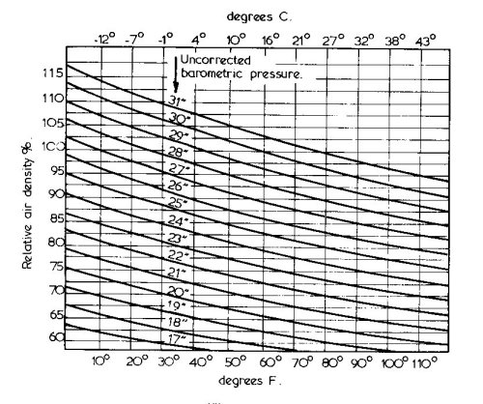Fig 1: Relative Air Density chart

Fluid Diodes

An electrical diode is a device which permits electricity to flow one way and not in reverse, a fluid diode is not a valve as such but a shaped passage which offers considerably more flow resistance one way compared with the reverse.

In the case of a two-stroke engine consider an inlet tract which resists any inlet charge spit back, or even better, traps it and returns it to the engine on the next cycle. There is no static blockage of the inlet tract, just a shape which alters the inlet gas dynamic behaviour. This behaviour was known and studied in the 1970's and gave promising results, up to 30% improvement in power in the 3000-4000 rpm and 20% in 4000-5000 rpm range and less as the revs rise. This is useful power for the race engine as long as the power is not actually less than standard, but it seems exactly what you would like for enduro and trials
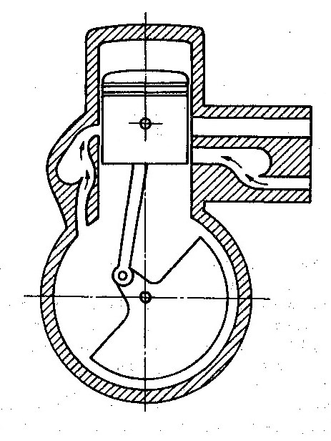Fig 2: Fluid Diode on intake

So why are these devices not commonplace on these types of engines?

One reason is that they are bulky, but I don’t see that as too much of a hindrance as long as they are light weight. They could easily be made of moulded plastic, and mounted behind engine and go where air filter and tools box as often sited. As with any resonant shape, it aids one frequency and detracts from another, and worked best in the lower frequencies

A second possibility is that the resonant plenum chamber would smooth out the engine induction pulses, and I have noticed that carburettors like a ‘signal’ to work properly. It is vague I know but that is what I think. With a significant plenum chamber between the engine and the carburettor there would be much less of a signal. My final reason is that it is much easier and cheaper just to fit a reed valve, they are simple and effective, and work at higher revs.

One who investigated the fluid diode was Eran Sher of Israel University, and some comment was included in the book he co-authored with John Heywood of MIT [SAE paper 830092, SAE book “The Two Stroke Cycle Engine”] . The essentially circular plenum chamber must have a radius of twice the inlet tract diameter, all the research papers agree on that, but I see no derivation or justification in these papers. This means that the plenum chamber needs to have a volume proportional to the carburettor choke size, in the case of my 32A this a 185cc as a minimum.

Verdict : If your club rules forbid reed valves on classic engines then this is interesting but a lot of work, and to get the 30% improvement achieved above, you need removable transfer port covers to reshape the transfers.

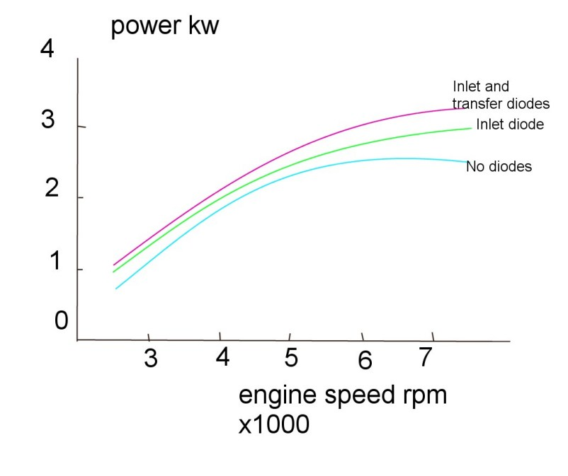
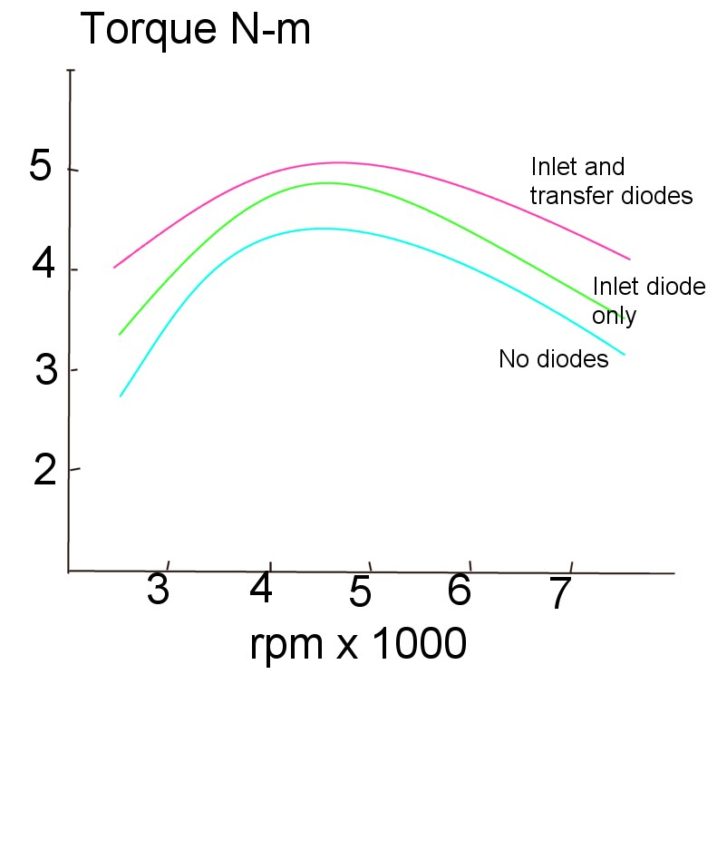
This shows the increased torque for implementing an inlet diode, and inlet+transfer diode, and increased power. Both charts are redrawn from data in the SAE paper 830092

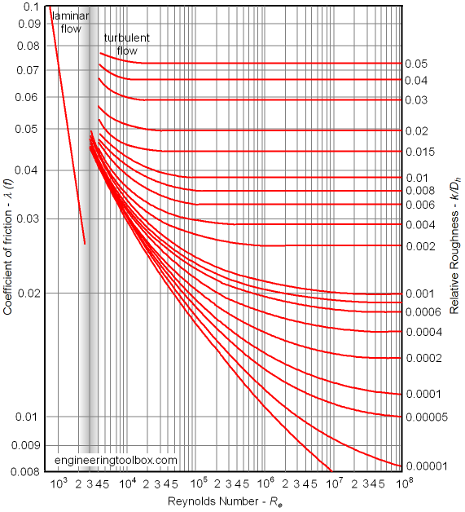Fig 3: Moody diagram

Lorem ipsum odor amet, consectetuer adipiscing elit. Eget eget orci lacus hendrerit ridiculus maecenas neque facilisi. Scelerisque leo sollicitudin ullamcorper per ultrices viverra per venenatis erat. Eu ridiculus fringilla ligula; tempus sagittis facilisis. Vel sapien ullamcorper ridiculus massa vel blandit. Blandit adipiscing parturient mus senectus volutpat sem laoreet libero. Finibus vivamus imperdiet class lacinia porta tellus purus interdum? Risus cras cras imperdiet et montes sociosqu nascetur urna.
Vehicula cubilia id varius phasellus sagittis mollis. Feugiat purus dis ante faucibus cursus aptent. Etiam dictum aptent elementum litora ridiculus facilisi blandit nullam. Felis lacus pulvinar nullam mauris platea torquent arcu. Ornare curabitur congue ipsum rutrum conubia vel conubia ultrices. Viverra tellus nibh nisl urna non augue. Dui diam feugiat mollis metus conubia accumsan sed inceptos mi. Platea nisi augue duis enim rutrum hac parturient blandit netus. Pharetra convallis dignissim, potenti tortor volutpat potenti dui.
Sed justo commodo auctor viverra dictum habitasse. Nulla volutpat fames vel augue condimentum. Molestie placerat gravida libero imperdiet penatibus nascetur vulputate. Malesuada scelerisque sit odio fusce, montes curae? Commodo curae viverra platea ridiculus tellus egestas ligula. Condimentum eu varius sed nunc turpis in leo. Montes magnis tincidunt pharetra class, imperdiet tempus nullam. Magna magna mollis inceptos suspendisse elementum. Vestibulum eget et nascetur magna donec eros habitant consequat. Mattis augue tristique nulla nam in ex.
Dis mollis nisl ligula per feugiat pharetra. Ultricies montes torquent molestie aenean feugiat. Vehicula quisque leo platea dui litora a. Parturient praesent nibh dui quisque quisque. Pulvinar donec rhoncus donec nibh leo sapien. Suscipit aliquet ultricies torquent suscipit luctus convallis neque curae. Eget mus pulvinar in placerat phasellus risus. Scelerisque et facilisi phasellus mollis aenean eros. Tristique senectus risus ex cras, semper imperdiet nec habitant vulputate?
Congue cursus conubia porttitor parturient quam. Iaculis felis phasellus interdum per maecenas natoque commodo. Laoreet ligula volutpat nam metus egestas pretium. Id ligula class mattis pharetra vehicula hendrerit platea pretium. Phasellus tellus placerat justo, ut tincidunt metus adipiscing. Aenean per feugiat dignissim varius eros. Vivamus sem sed nulla suspendisse venenatis nam eget scelerisque. Quisque tristique pellentesque tempus vestibulum ultrices mauris integer. Faucibus ante netus massa donec eget volutpat.
Lorem ipsum odor amet, consectetuer adipiscing elit. Eget eget orci lacus hendrerit ridiculus maecenas neque facilisi. Scelerisque leo sollicitudin ullamcorper per ultrices viverra per venenatis erat. Eu ridiculus fringilla ligula; tempus sagittis facilisis. Vel sapien ullamcorper ridiculus massa vel blandit. Blandit adipiscing parturient mus senectus volutpat sem laoreet libero. Finibus vivamus imperdiet class lacinia porta tellus purus interdum? Risus cras cras imperdiet et montes sociosqu nascetur urna.
Vehicula cubilia id varius phasellus sagittis mollis. Feugiat purus dis ante faucibus cursus aptent. Etiam dictum aptent elementum litora ridiculus facilisi blandit nullam. Felis lacus pulvinar nullam mauris platea torquent arcu. Ornare curabitur congue ipsum rutrum conubia vel conubia ultrices. Viverra tellus nibh nisl urna non augue. Dui diam feugiat mollis metus conubia accumsan sed inceptos mi. Platea nisi augue duis enim rutrum hac parturient blandit netus. Pharetra convallis dignissim, potenti tortor volutpat potenti dui.
Sed justo commodo auctor viverra dictum habitasse. Nulla volutpat fames vel augue condimentum. Molestie placerat gravida libero imperdiet penatibus nascetur vulputate. Malesuada scelerisque sit odio fusce, montes curae? Commodo curae viverra platea ridiculus tellus egestas ligula. Condimentum eu varius sed nunc turpis in leo. Montes magnis tincidunt pharetra class, imperdiet tempus nullam. Magna magna mollis inceptos suspendisse elementum. Vestibulum eget et nascetur magna donec eros habitant consequat. Mattis augue tristique nulla nam in ex.
Dis mollis nisl ligula per feugiat pharetra. Ultricies montes torquent molestie aenean feugiat. Vehicula quisque leo platea dui litora a. Parturient praesent nibh dui quisque quisque. Pulvinar donec rhoncus donec nibh leo sapien. Suscipit aliquet ultricies torquent suscipit luctus convallis neque curae. Eget mus pulvinar in placerat phasellus risus. Scelerisque et facilisi phasellus mollis aenean eros. Tristique senectus risus ex cras, semper imperdiet nec habitant vulputate?
Congue cursus conubia porttitor parturient quam. Iaculis felis phasellus interdum per maecenas natoque commodo. Laoreet ligula volutpat nam metus egestas pretium. Id ligula class mattis pharetra vehicula hendrerit platea pretium. Phasellus tellus placerat justo, ut tincidunt metus adipiscing. Aenean per feugiat dignissim varius eros. Vivamus sem sed nulla suspendisse venenatis nam eget scelerisque. Quisque tristique pellentesque tempus vestibulum ultrices mauris integer. Faucibus ante netus massa donec eget volutpat.
Lorem ipsum odor amet, consectetuer adipiscing elit. Eget eget orci lacus hendrerit ridiculus maecenas neque facilisi. Scelerisque leo sollicitudin ullamcorper per ultrices viverra per venenatis erat. Eu ridiculus fringilla ligula; tempus sagittis facilisis. Vel sapien ullamcorper ridiculus massa vel blandit. Blandit adipiscing parturient mus senectus volutpat sem laoreet libero. Finibus vivamus imperdiet class lacinia porta tellus purus interdum? Risus cras cras imperdiet et montes sociosqu nascetur urna.
Vehicula cubilia id varius phasellus sagittis mollis. Feugiat purus dis ante faucibus cursus aptent. Etiam dictum aptent elementum litora ridiculus facilisi blandit nullam. Felis lacus pulvinar nullam mauris platea torquent arcu. Ornare curabitur congue ipsum rutrum conubia vel conubia ultrices. Viverra tellus nibh nisl urna non augue. Dui diam feugiat mollis metus conubia accumsan sed inceptos mi. Platea nisi augue duis enim rutrum hac parturient blandit netus. Pharetra convallis dignissim, potenti tortor volutpat potenti dui.
Sed justo commodo auctor viverra dictum habitasse. Nulla volutpat fames vel augue condimentum. Molestie placerat gravida libero imperdiet penatibus nascetur vulputate. Malesuada scelerisque sit odio fusce, montes curae? Commodo curae viverra platea ridiculus tellus egestas ligula. Condimentum eu varius sed nunc turpis in leo. Montes magnis tincidunt pharetra class, imperdiet tempus nullam. Magna magna mollis inceptos suspendisse elementum. Vestibulum eget et nascetur magna donec eros habitant consequat. Mattis augue tristique nulla nam in ex.
Dis mollis nisl ligula per feugiat pharetra. Ultricies montes torquent molestie aenean feugiat. Vehicula quisque leo platea dui litora a. Parturient praesent nibh dui quisque quisque. Pulvinar donec rhoncus donec nibh leo sapien. Suscipit aliquet ultricies torquent suscipit luctus convallis neque curae. Eget mus pulvinar in placerat phasellus risus. Scelerisque et facilisi phasellus mollis aenean eros. Tristique senectus risus ex cras, semper imperdiet nec habitant vulputate?
Congue cursus conubia porttitor parturient quam. Iaculis felis phasellus interdum per maecenas natoque commodo. Laoreet ligula volutpat nam metus egestas pretium. Id ligula class mattis pharetra vehicula hendrerit platea pretium. Phasellus tellus placerat justo, ut tincidunt metus adipiscing. Aenean per feugiat dignissim varius eros. Vivamus sem sed nulla suspendisse venenatis nam eget scelerisque. Quisque tristique pellentesque tempus vestibulum ultrices mauris integer. Faucibus ante netus massa donec eget volutpat.
Lorem ipsum odor amet, consectetuer adipiscing elit. Eget eget orci lacus hendrerit ridiculus maecenas neque facilisi. Scelerisque leo sollicitudin ullamcorper per ultrices viverra per venenatis erat. Eu ridiculus fringilla ligula; tempus sagittis facilisis. Vel sapien ullamcorper ridiculus massa vel blandit. Blandit adipiscing parturient mus senectus volutpat sem laoreet libero. Finibus vivamus imperdiet class lacinia porta tellus purus interdum? Risus cras cras imperdiet et montes sociosqu nascetur urna.
Vehicula cubilia id varius phasellus sagittis mollis. Feugiat purus dis ante faucibus cursus aptent. Etiam dictum aptent elementum litora ridiculus facilisi blandit nullam. Felis lacus pulvinar nullam mauris platea torquent arcu. Ornare curabitur congue ipsum rutrum conubia vel conubia ultrices. Viverra tellus nibh nisl urna non augue. Dui diam feugiat mollis metus conubia accumsan sed inceptos mi. Platea nisi augue duis enim rutrum hac parturient blandit netus. Pharetra convallis dignissim, potenti tortor volutpat potenti dui.
Sed justo commodo auctor viverra dictum habitasse. Nulla volutpat fames vel augue condimentum. Molestie placerat gravida libero imperdiet penatibus nascetur vulputate. Malesuada scelerisque sit odio fusce, montes curae? Commodo curae viverra platea ridiculus tellus egestas ligula. Condimentum eu varius sed nunc turpis in leo. Montes magnis tincidunt pharetra class, imperdiet tempus nullam. Magna magna mollis inceptos suspendisse elementum. Vestibulum eget et nascetur magna donec eros habitant consequat. Mattis augue tristique nulla nam in ex.
Dis mollis nisl ligula per feugiat pharetra. Ultricies montes torquent molestie aenean feugiat. Vehicula quisque leo platea dui litora a. Parturient praesent nibh dui quisque quisque. Pulvinar donec rhoncus donec nibh leo sapien. Suscipit aliquet ultricies torquent suscipit luctus convallis neque curae. Eget mus pulvinar in placerat phasellus risus. Scelerisque et facilisi phasellus mollis aenean eros. Tristique senectus risus ex cras, semper imperdiet nec habitant vulputate?
Congue cursus conubia porttitor parturient quam. Iaculis felis phasellus interdum per maecenas natoque commodo. Laoreet ligula volutpat nam metus egestas pretium. Id ligula class mattis pharetra vehicula hendrerit platea pretium. Phasellus tellus placerat justo, ut tincidunt metus adipiscing. Aenean per feugiat dignissim varius eros. Vivamus sem sed nulla suspendisse venenatis nam eget scelerisque. Quisque tristique pellentesque tempus vestibulum ultrices mauris integer. Faucibus ante netus massa donec eget volutpat.

