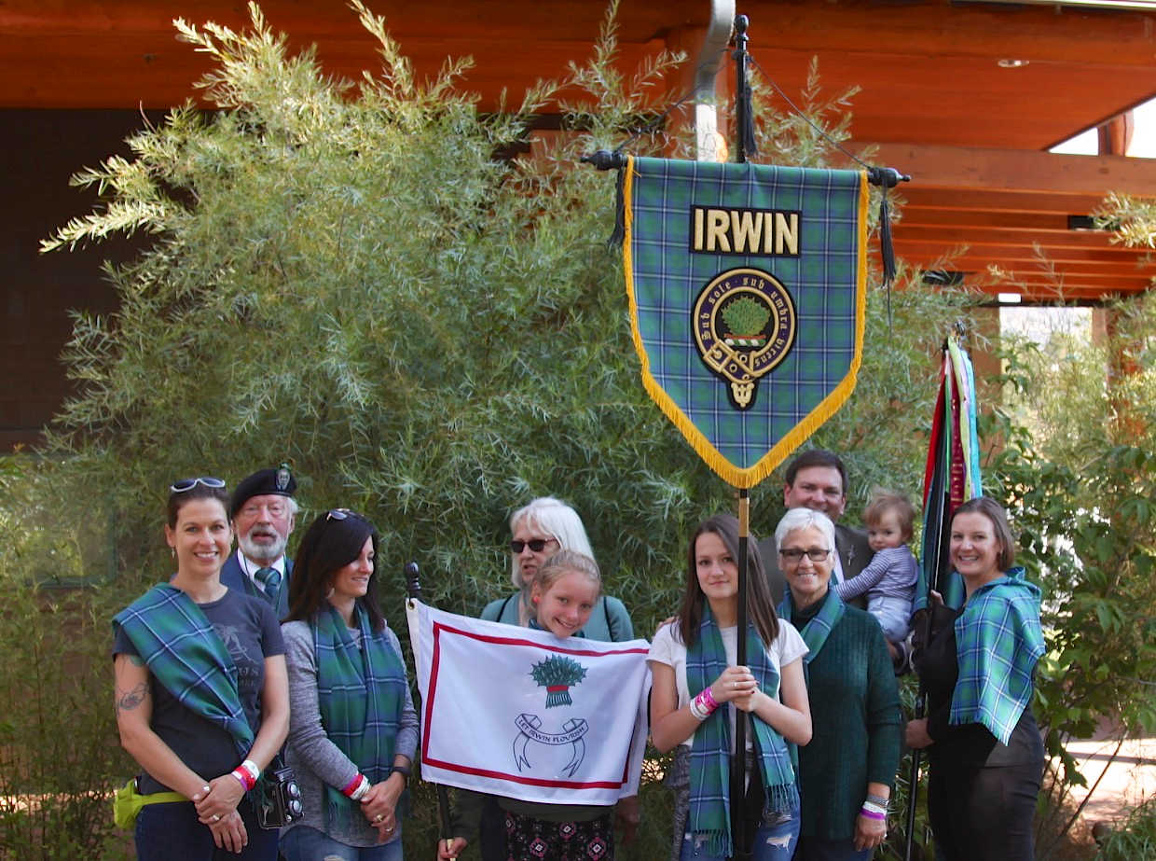
Aye, and it was a banner year at the running of the 42nd Longs Peak Festival for the Irwin Clan. The Festival is the largest in the Rocky Mountain Region, reputed to be the largest between the Mississippi River and California with three-day attendance of 60,000+.
Over a hundred vendors selling Celtic merchandize, 18 food vendors and 50+ events. Eighteen with Irwin family heritage came visiting the Clan Irwin tent, man’d and woman’d by clan members David and Pamela Irwin, Amy Webb, Ben Irwin and family. One of the visitors was JoAnne Lafley who has joined the Clan. Welcome JoAnne.

- Number of Irwin Clan/name/kin who signed guest register: 18
- Number of new Clan members signed up: 1
- Number of visitors to the Clan Irwin tent: 51
- Number of visitors who received assistance in determining their Clan association: 19
- Festival Attendance 60,000+

by David Harlan Irwin (Convener)

